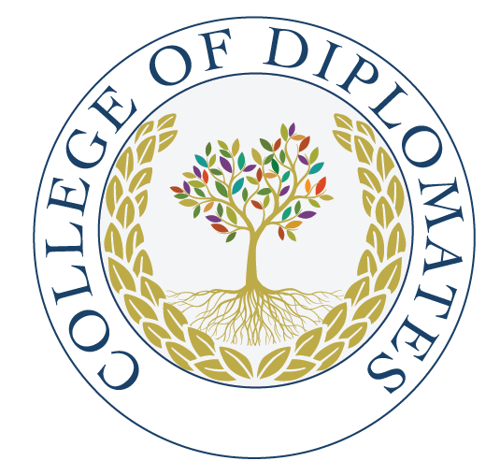

College of Diplomates of the ABE
14th Annual Board Review Course and Scientific Update
February 7- 9, 2025
(All Times are Central)
Hosted via Zoom

DAY 1: Friday, February 7, 2025

7:45 a.m. Welcome Remarks
Dr. S. Craig Schneider President
Dr., AAE President

8:00am – 9:30am Diagnosis/Periapical Disease (1.5 CE credits)
Dr. David Landwehr

9:45am- 11:15am Medically Complex Patients/Clinical Pharmacology (2.0 CE credits)
Dr. Lauren Patton

12:00pm -1:30pm Endodontic Microbiology (1.5 CE credits)
Dr. Anil Kishen

1:45pm – 3:45pm Trauma & Resorption (2.0 CE credits)
Dr. Frederic Barnett

4:00pm- 5:30pm Endodontic Surgery (1.5 CE Credits)
TBD

DAY 2: Saturday, February 8, 2025

8:00am- 10:00am Inflammation and Immunology (2.0 CE Credits)
Dr. Asma Khan

10:30- 12:30pm Outcomes/Evidence-based endodontics/Prognosis (2.0 CE Credits)
TBD

1:30pm – 2:45pm Endodontic Radiology/CBCT (focusing on imaging and including sinus pathosis) (1.5CE Credits)
Dr. Bruno Azevedo

3:00pm- 4:30pm Oral Pathology (1.5 CE Credits)
Dr. Vijay Parashar

DAY 3: Sunday, February 9, 2025

8:00am- 9:30am Regenerative Endo & Vital Pulp Therapy (1.5 CE credits)
Dr. George Huang

9:45am- 10:15am ABE Boardwalk (.5 CE credits)
TBD

10:30am- 12pm Oral Board Preparation/Case Portfolio (1.5 CE credits)
Dr. John Neal

